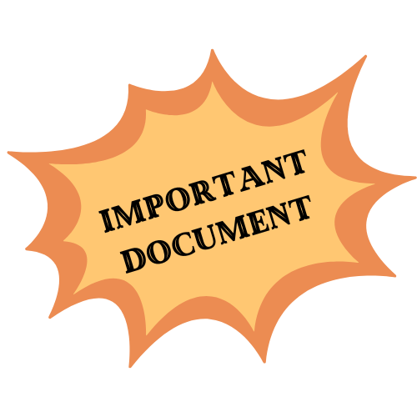
Local Association Membership Renewal Form 2023-2024

It is the mission of The Quebec Federation of Home and School Associations to “enhance the education and general well being of children and youth,” and “to promote the involvement of parents, students, educators and the community at large in the advancement of learning” in the public school system of Quebec. In so doing, the QFHSA “acts as a voice for parents”.
(Taken from the Mission Statement of the QFHSA)
Without you the members, QFHSA has no reason to exist. Without QFHSA, local Home and School Associations cannot exist.
Together we can achieve our goals both provincially and locally. For this reason, we are asking you, our member schools, to renew your commitment to Home and School. It is through your support of QFHSA that you enable QFHSA to support you and your children.

Please fill out the following form at your first Home and School meeting and return it, signed and dated, to our office by mail or scanned and emailed by September 29th, 2023.

Name of Association: _____________________________________________
We, the undersigned, on behalf of our Home and School Association, agree to fulfill the following requirements in order that our Home and School Association remains a member in good standing with the Quebec Federation of Home and School Associations Inc.:
1. At the Annual General Assembly, Home and School will be authorized by the parents, as a recognized parent body in the school.
2. Prior to September 29th, 2023, we will submit the administration fee of $50.00, along with a copy of the new Executive list. The administration fee can also be submitted in June of the previous school year.
3. Beginning in September, at the latest, we will hold a membership campaign with the minimum goal to have 10% of our school families become members.
4. We will submit our first 2023-24 membership list and membership fees to the QFHSA office by October 31st, 2023 and then continue to submit additional new member’s information to the QFHSA at the end of each month. We understand that to hold onto our members’ registration money is a breach of their trust and could jeopardize their insurance coverage and ours. As of December 1st, 2023, delinquent associations will not be included on the QFHSA insurance policy renewal.
5. We will submit a President’s End-of-Year Activity Report and a Treasurer’s End-of-Year Financial Report to QFHSA at the end of June of this school year, or a month following our fiscal year-end.
6. We understand that it is our responsibility to send at least one voting delegate to the Annual General Meeting to represent our Association. If we are unable to do this, we will provide the QFHSA with a valid reason.
7. We understand that it is to our benefit that our Executive members attend the leadership workshops (in September), and to extend the invitation to our general membership to attend the Annual Fall Conference.
8. We understand that these requirements are part of our role as a Home and School Association. They are obligations both to our members and to the Quebec Federation of Home and School Associations.
9. Furthermore, we understand that if we do not fulfill our obligations as stated, and are unable to offer a valid reason, the Quebec Federation of Home and School Associations has the authority to require us to close our bank account and to cease all activities as a Home and School Association.
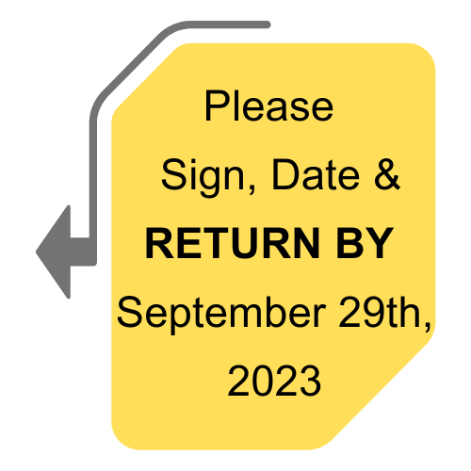
President: _________________________________ _________________________________ _________________
Please print name Signature Date

Treasurer: _________________________________ _________________________________ _________________
Please print name Signature Date

Membership Chair or
Secretary: _________________________________ _________________________________ _________________
Please print name Signature Date

