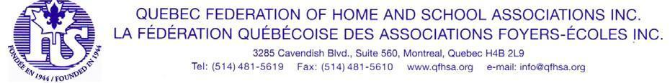

May 2023

Discretionary Voting Powers

To: All Local Home and School Associations
From: AGM General Arrangements Committee

Re: AGM 2023

Often matters come up at the AGM that are unforeseen. It is recommended that your local Association give the voting delegate who will be attending the AGM on your behalf discretion to vote on these and all other matters.

Emergency resolutions are often introduced due to late-breaking news, especially where education is concerned. Please pass the following motion at your upcoming Home and School meeting.

MOTION:

(Your school name) Home & School Association gives our delegate the power to vote on our behalf, at their own discretion, at the 2023 Annual General Meeting of the Quebec Federation of Home and School Associations Inc.

Delegate: (fill in the name)

[1] ________________________________________________________

Please attach this Motion to your Voting Credentials Form, which lists your Association’s Voting
Delegate and Alternate. Thank you.

2023 QFHSA Annual General Meeting

